REPORT FOR TASK 4, VARIANT 8

1. First subtask:

a:

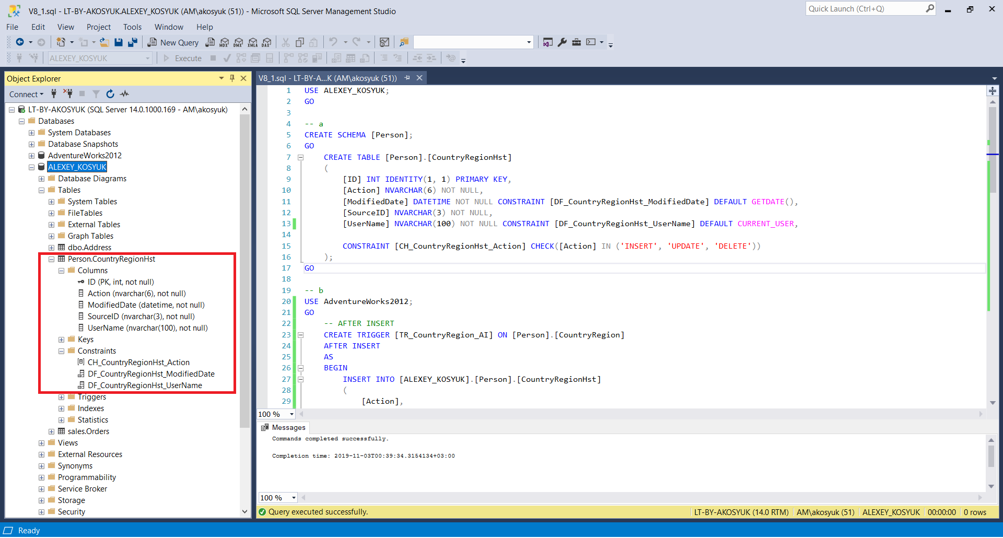

b:

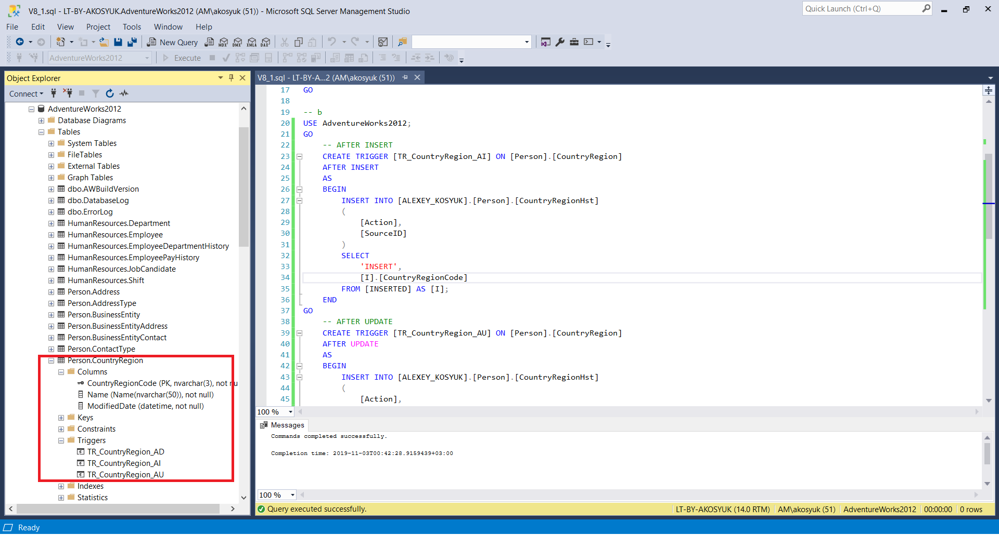

c:

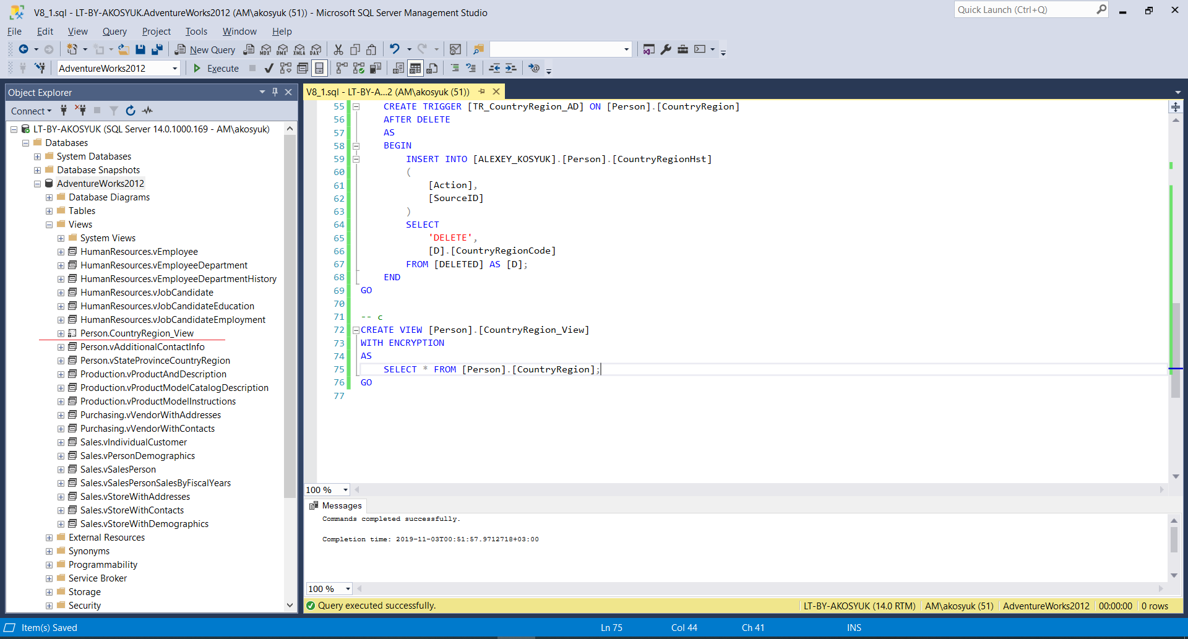

d:

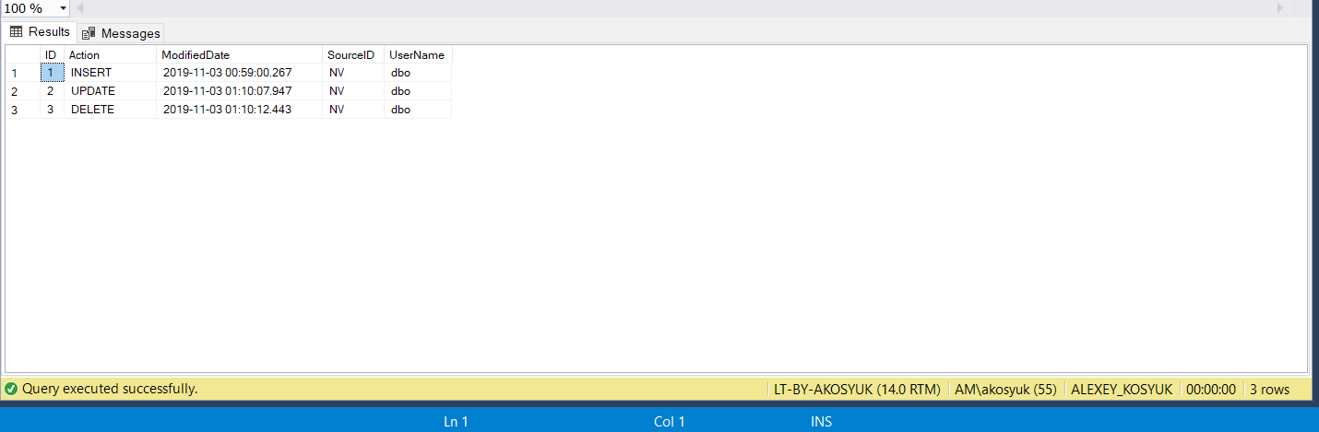

2. Second subtask: